**ELEC 204 Digital Design Preliminary Lab Report**

Preliminary Lab 01

Name: Umur Demircioğlu

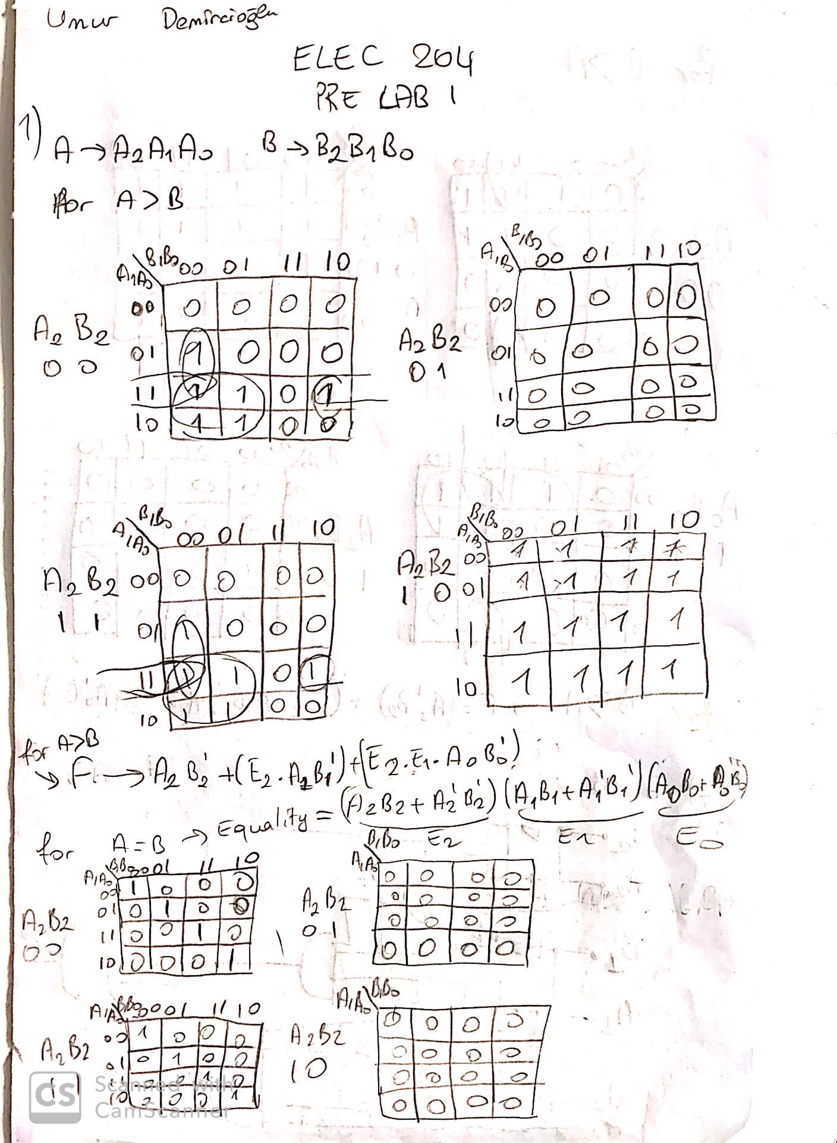Date: 10/10/2019

